1. **Describe the role of TelephonyManager and its functions in Android.**

Ans :

The TelephonyManager is a system service in Android that provides access to information about the telephony services on the device. It allows apps to interact with the mobile network, retrieve network/operator-related details, and monitor telephony states.

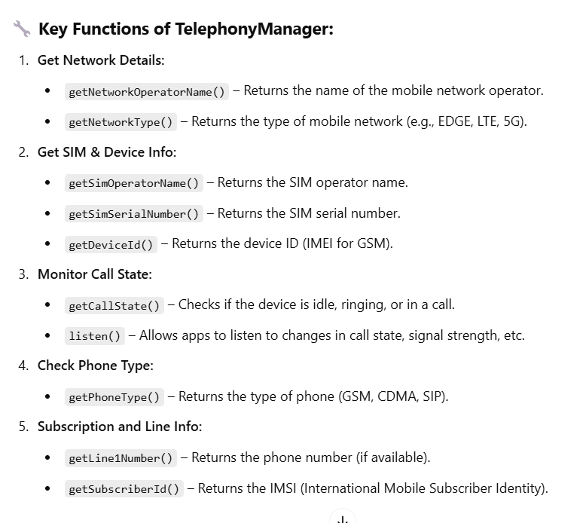

1. **Explain how you can make phone calls and send SMS using Android APIs. Mention the required permissions.**

**Ans:**

Android provides built-in APIs to make phone calls and send SMS messages programmatically.

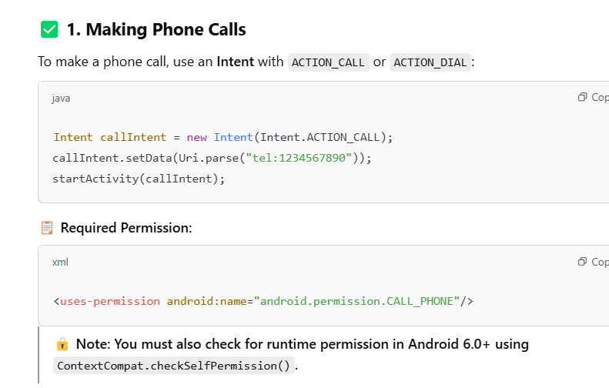

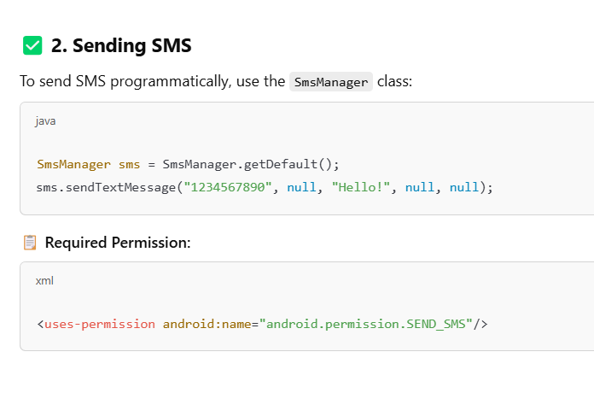

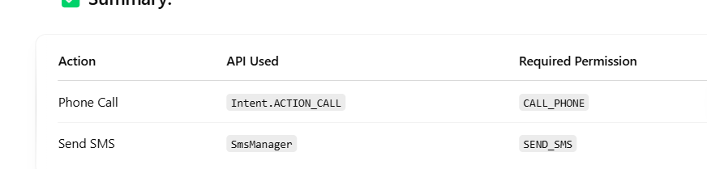

1. **What is TextToSpeech in Android? Explain how to initialize it, set language, and use the speak method.**

**Ans:** TextToSpeech (TTS) is a class in Android that converts text into spoken voice output. It is commonly used in apps for accessibility, reading messages, or giving voice feedback to users.

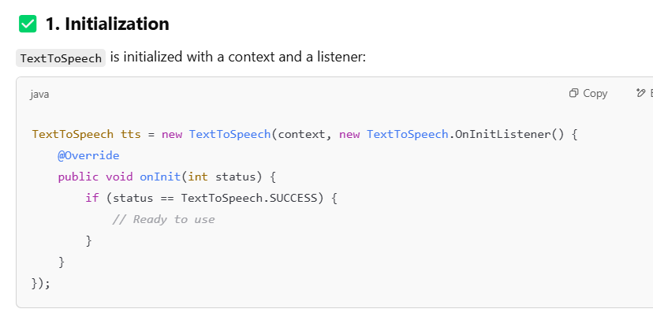

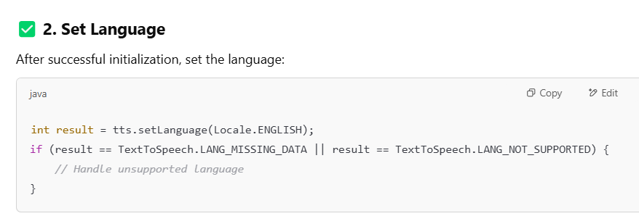

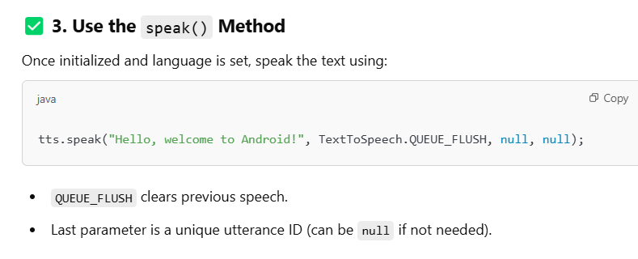

1. **Discuss the process and code required to convert speech to text in Android.**

**Ans:**

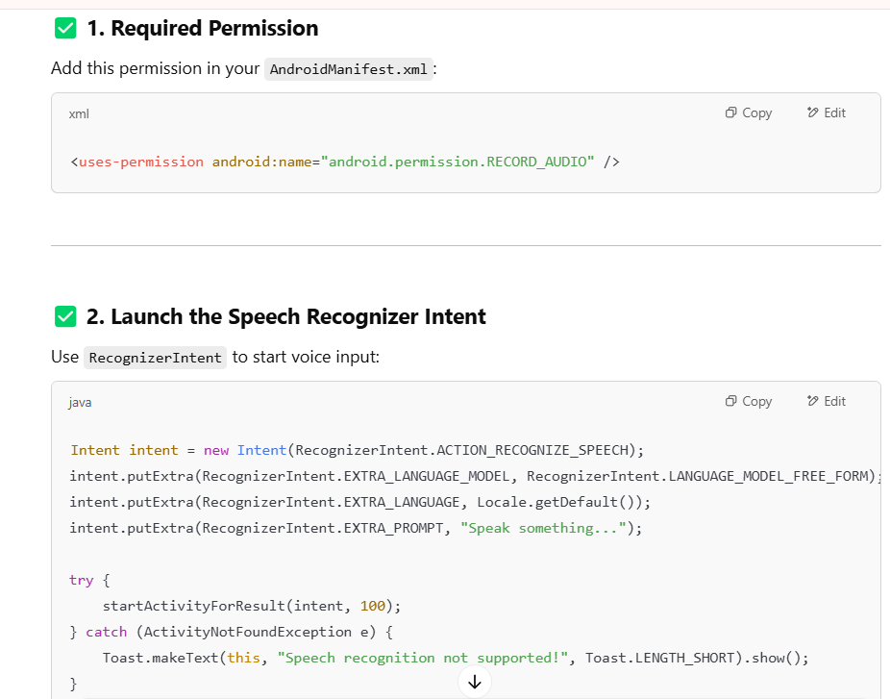

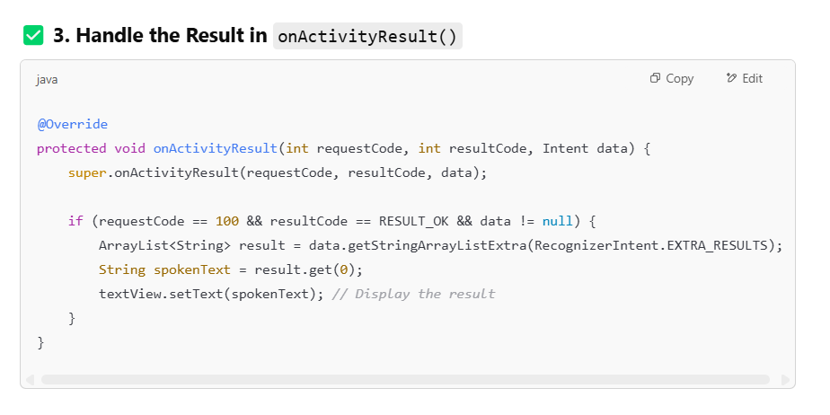

1. **Explain how location-based services work in Android. How can user location be retrieved?**

**Ans:** Location-Based Services (LBS) in Android allow apps to access the device’s geographical location using GPS, Wi-Fi, or cellular networks. They are commonly used in navigation, ride-sharing, weather apps, etc.Android provides location services through the Fused Location Provider API, which combines multiple sources for accurate and battery-efficient location tracking.

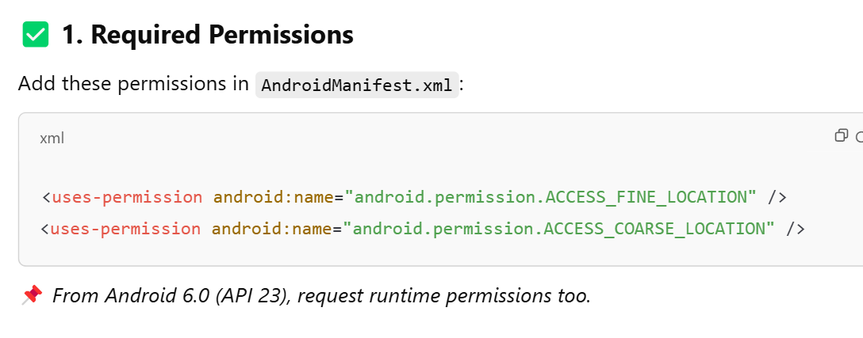

1. **Use FusedLocationProviderClient :** This is the recommended API for getting location:

FusedLocationProviderClient fusedLocationClient = LocationServices.getFusedLocationProviderClient(this);

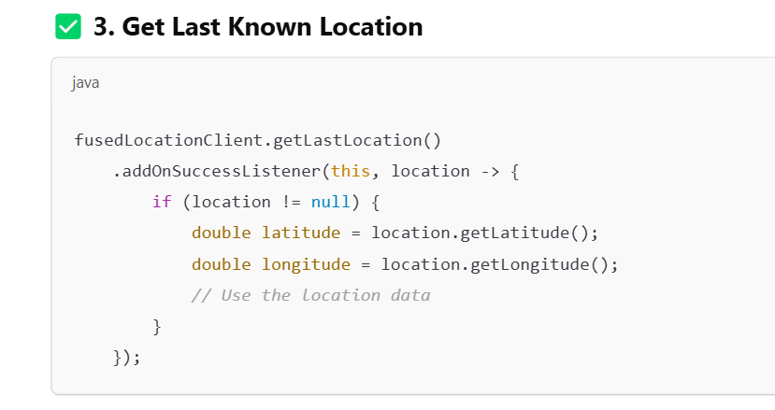

1. **Describe how to implement Google Maps in an Android application.ans** :

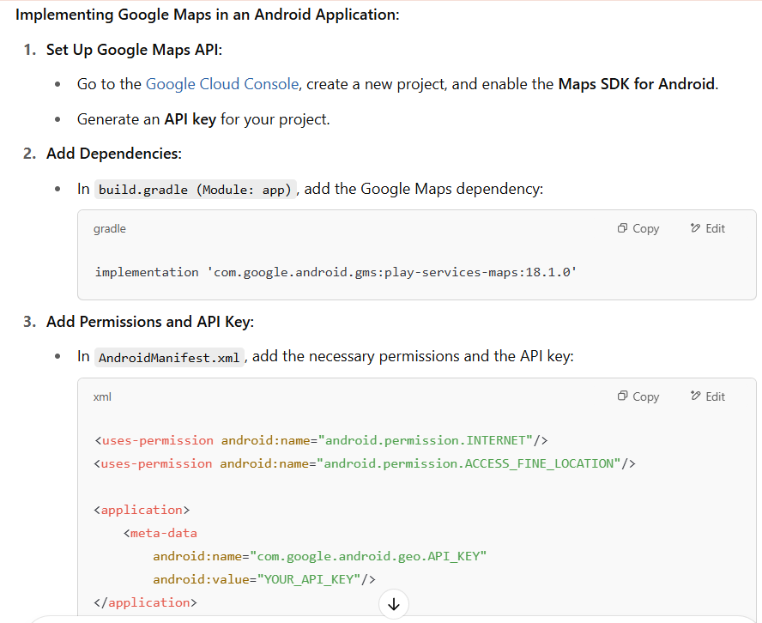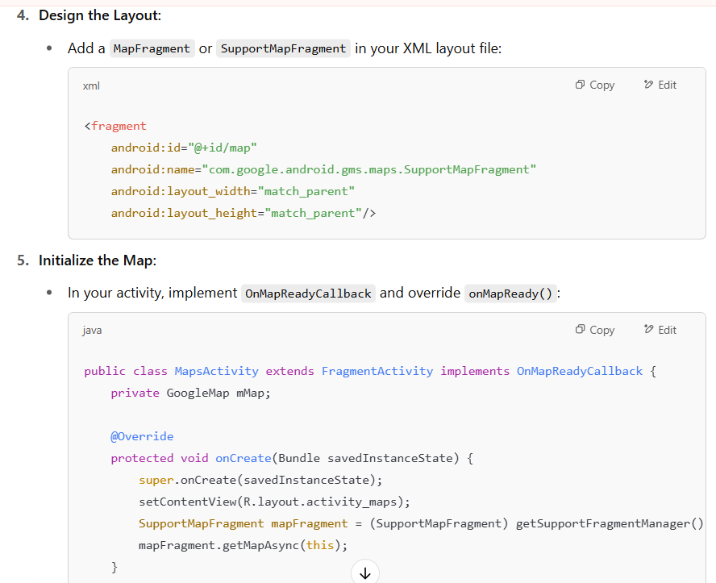

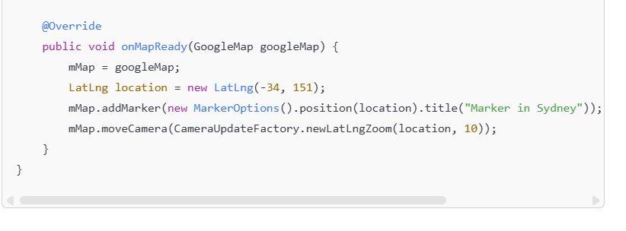

**7.Compare and contrast text-to-speech and speech-to-text functionality in Android with use cases.**

